UPGRADING THE BUILDINGS OF CROWN CHURCH

The final phase of the upgrade begun in 2020 and on which we are now embarking, involves the addition of ramp access to new automated glass doors which will become the main entrance to our buildings. These will lead into a new-build bright multi-use foyer and reception area which will lead straight through to the Sanctuary by extending the current transept windows -spaces to the ground to make archways. We will partly demolish the existing outdated 1980’s extension to do this.

We anticipate that this will significantly enhance the public's perception of the church, as floor-to-ceiling windows will provide clear visibility from the street. Currently the Victorian aspect of the building belies the activities and ethos of the congregation, and the existing wheelchair/pram access is more of an obstacle course, particularly on a windy day when a fierce draught pulls the door out of even an able-bodied person’s hands. From a stranger’s point of view, the provision of a clear main entrance does away with confusion over which of our five doors to use.

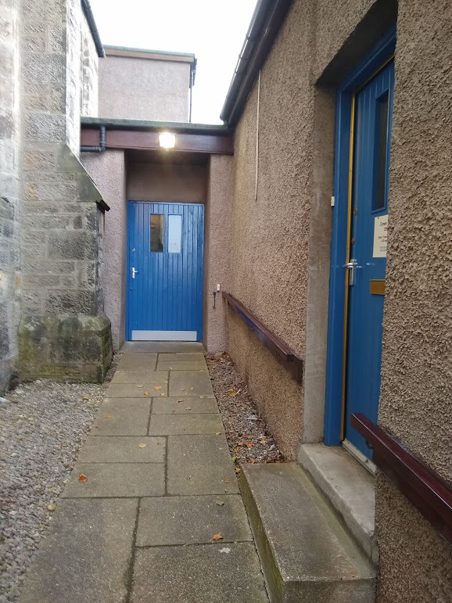
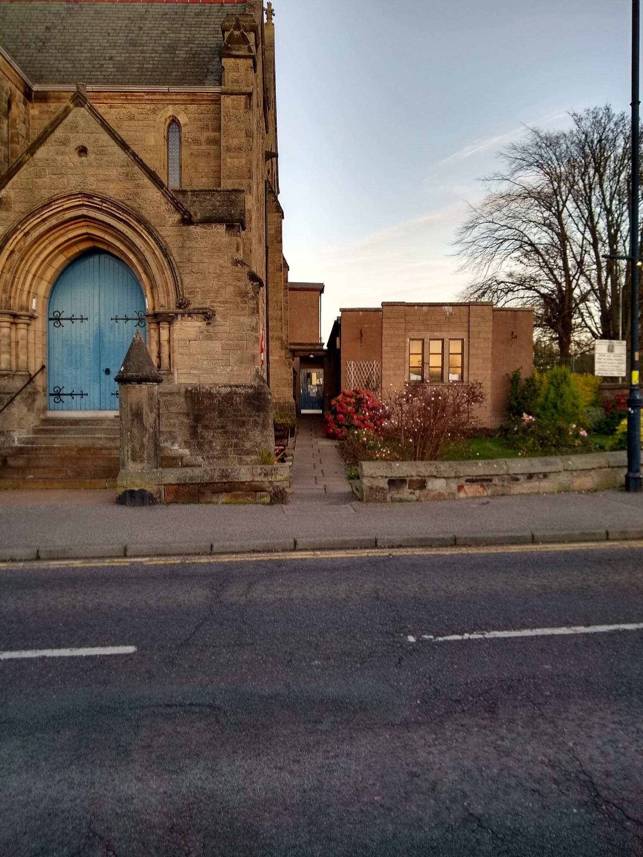

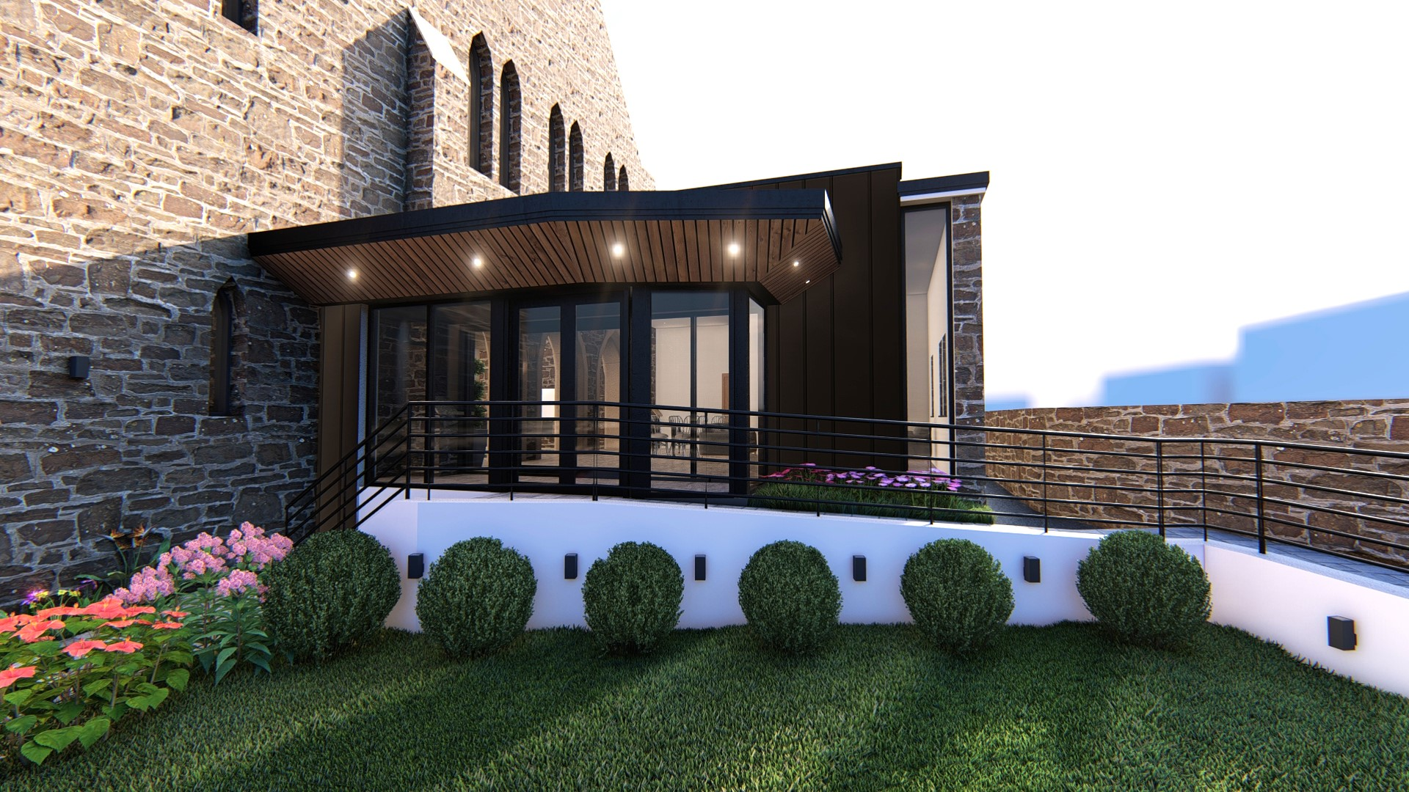

The current extension and narrow Architect’s image of the new ramp accessible entrance automatic doors and long windows.

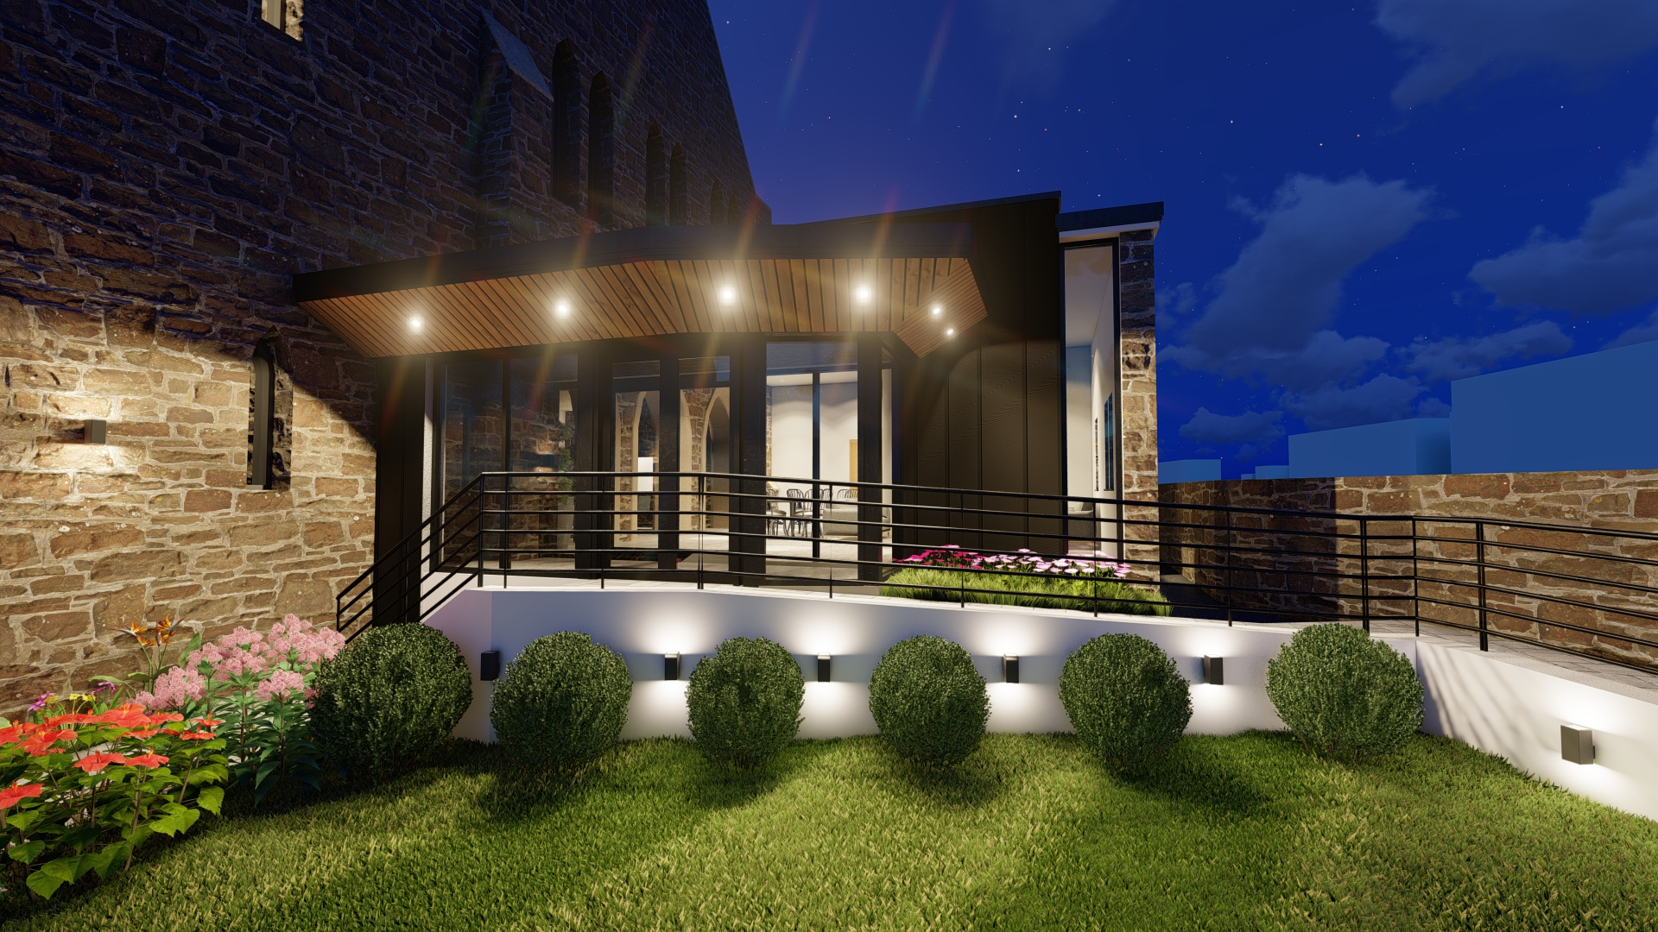

Night-time image and welcoming lighting.

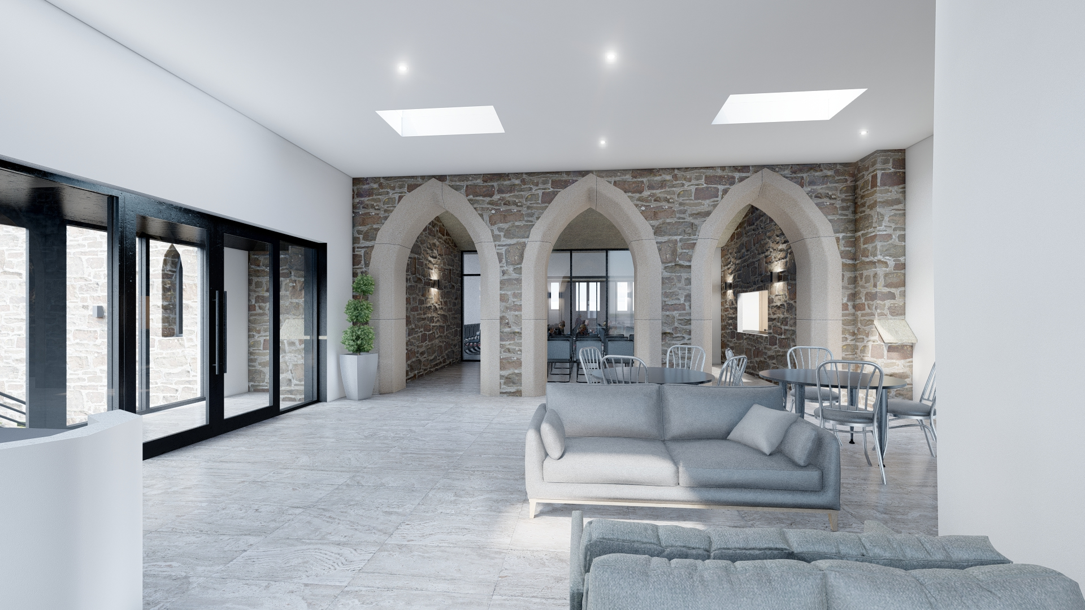

Architect’s image of the new foyer leading directly into the Sanctuary.

The visible, inviting space will encourage community involvement and make the church more approachable. The Crown area does not have a community centre, and we are increasingly welcoming more community groups to use our spaces. The new, easily accessible flexible spaces we will be able to offer will, we hope, increase this use, thus adding to our financial sustainability, and that in turn will secure our future as both a centre for worship and a community resource.

