Crown Church Halls
In 2021, our upper hall was refurbished. It was a pleasure to work with our Architect, Billy Reynolds from Dingwall, and our Contractor Ian Ferguson, Kiltarlity. As the construction industry had been able to return to work while most of us were still keeping safe at home, minimal disruption was felt by the congregation.
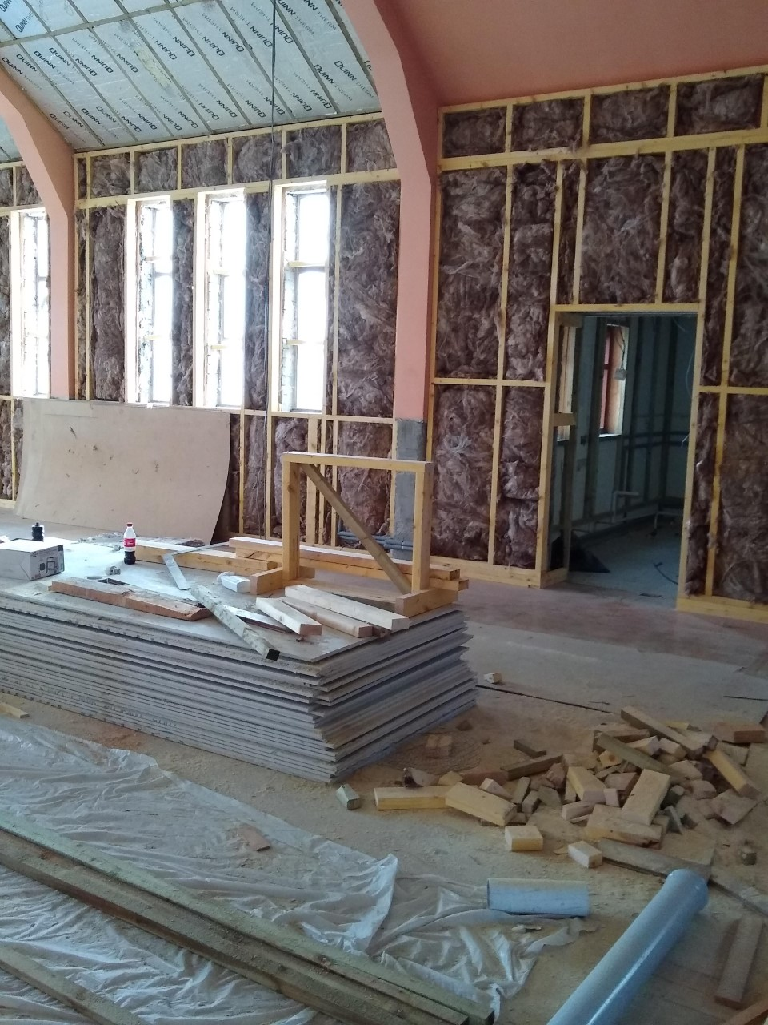

We were concerned to reduce our carbon footprint, and have ensured the walls and ceiling are fully insulated.
This is what you no longer see!

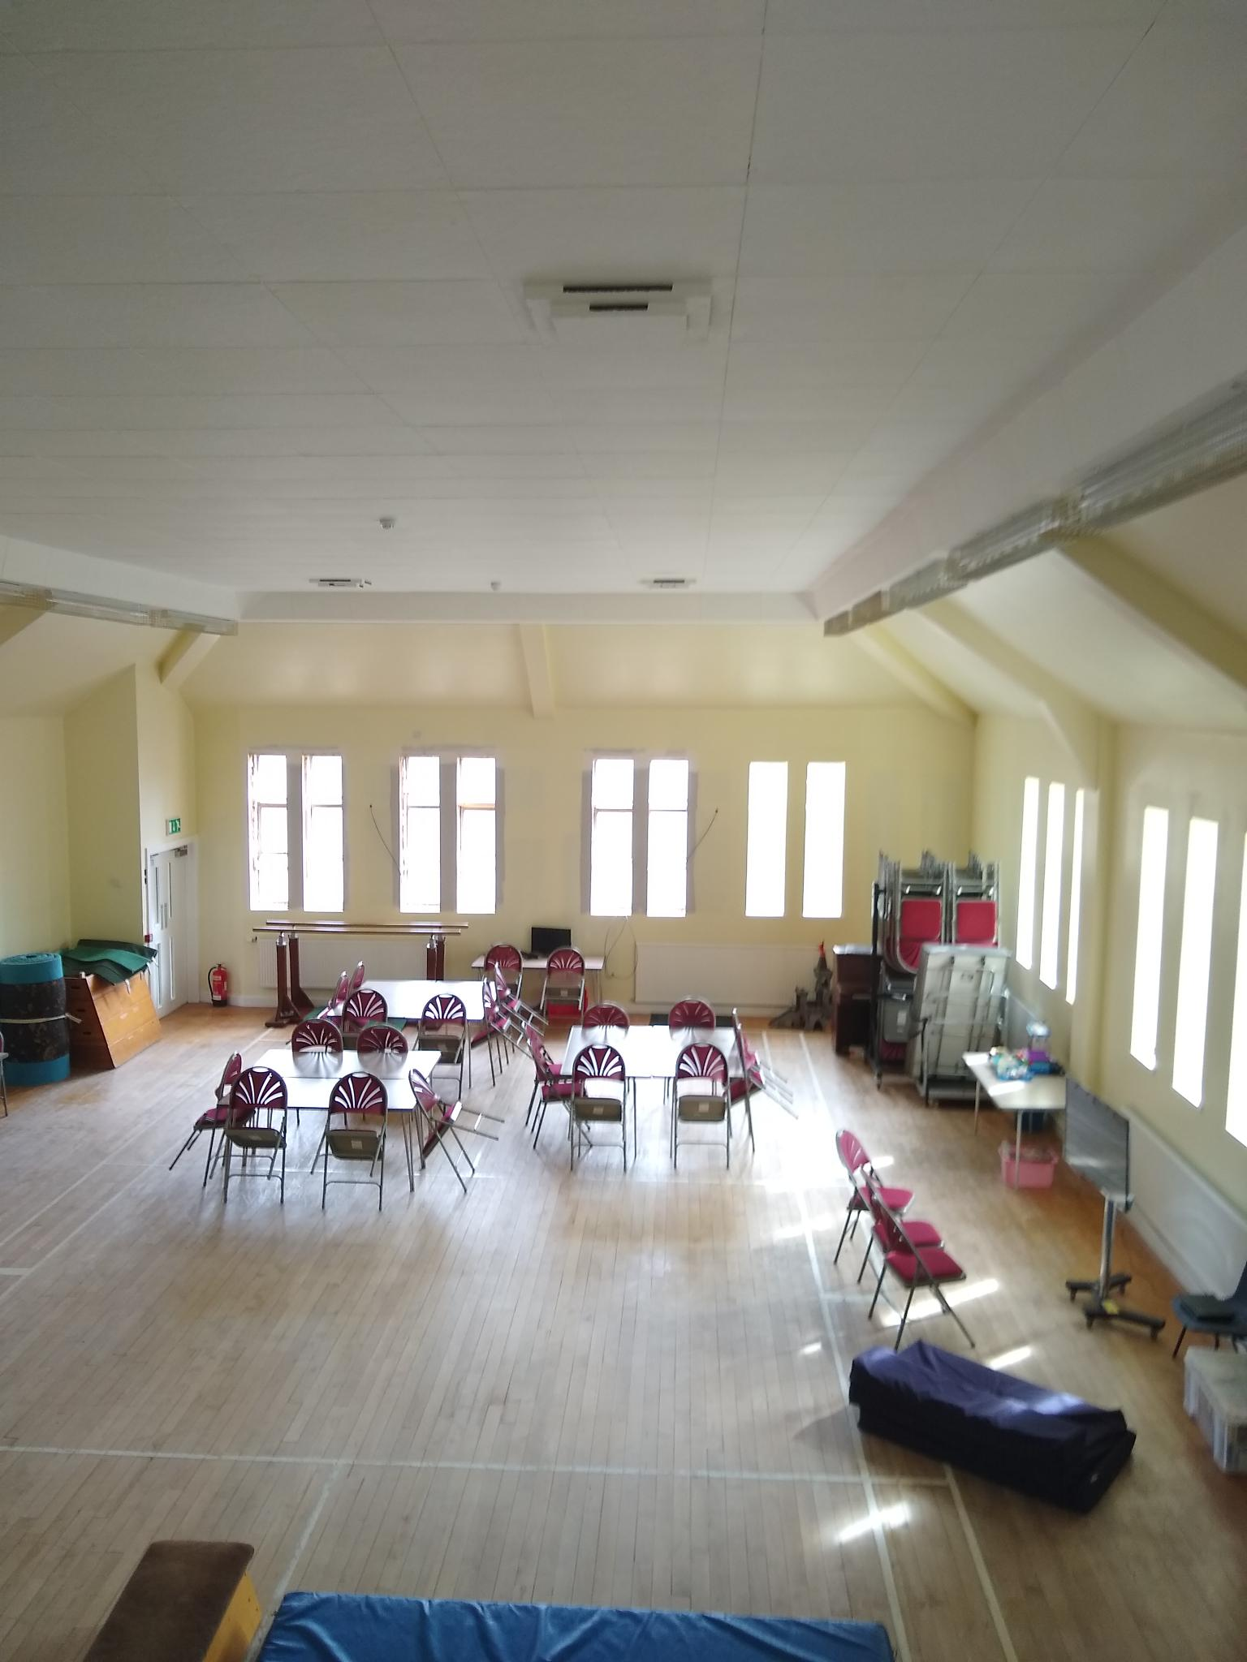

The original windows have been replaced with double glazed clear glass, and we have fitted new doors to keep out any draughts. The radiators are now fitted with thermostats. A pleasing daffodil yellow ensures a bright and warm aspect.

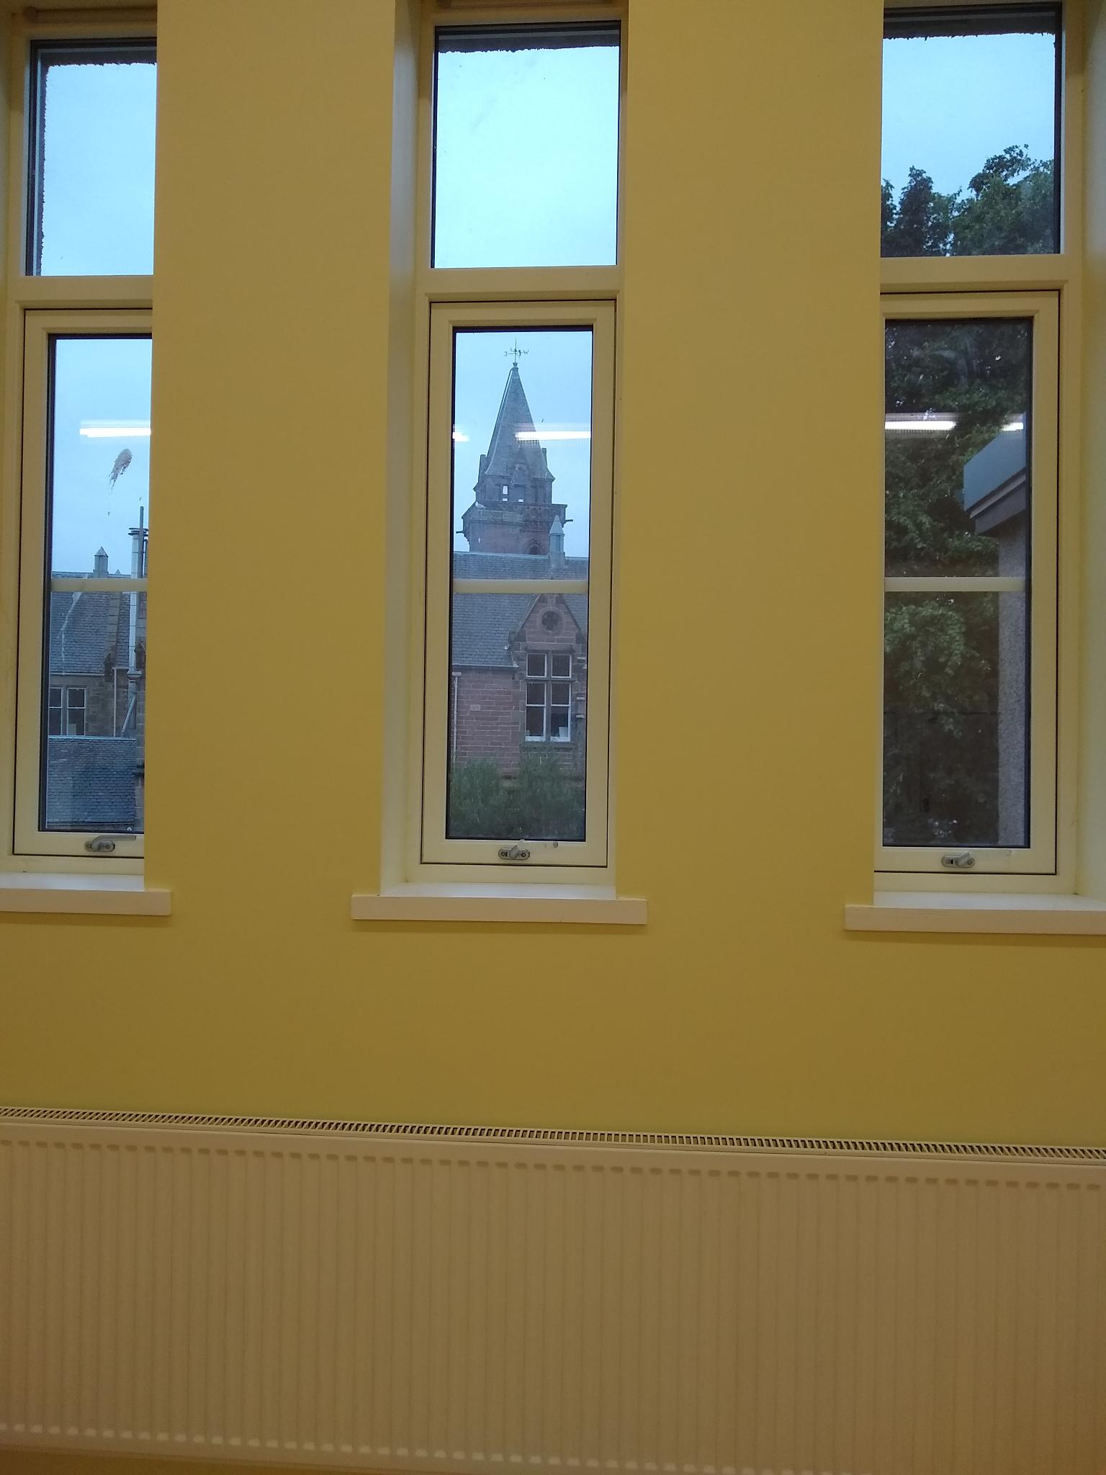

It is a new experience to be able to see the school through the clear windows.

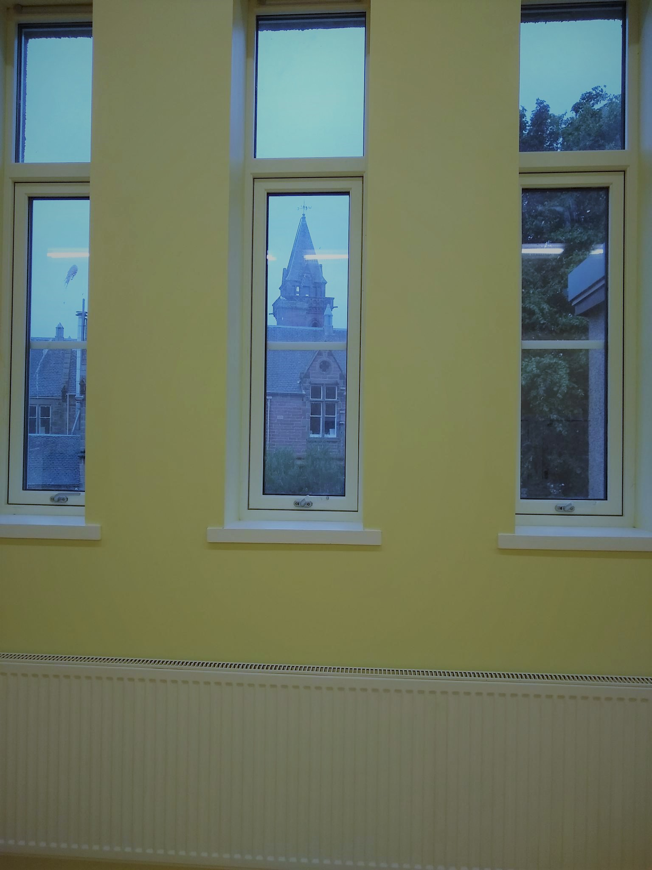

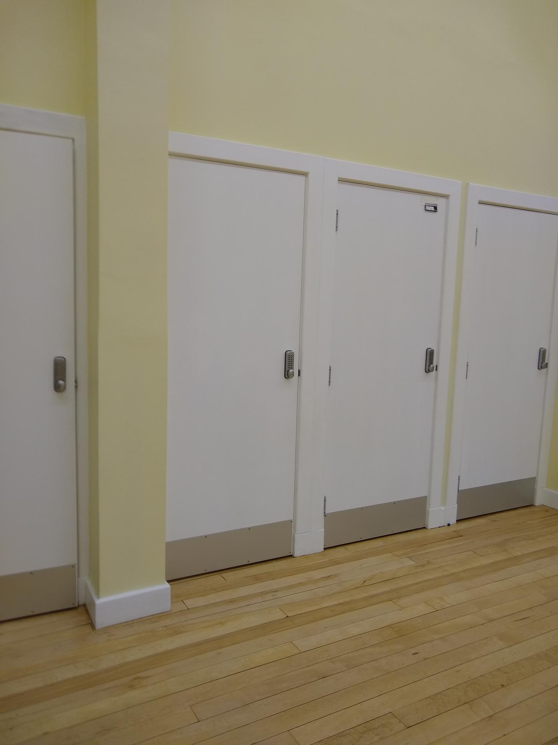

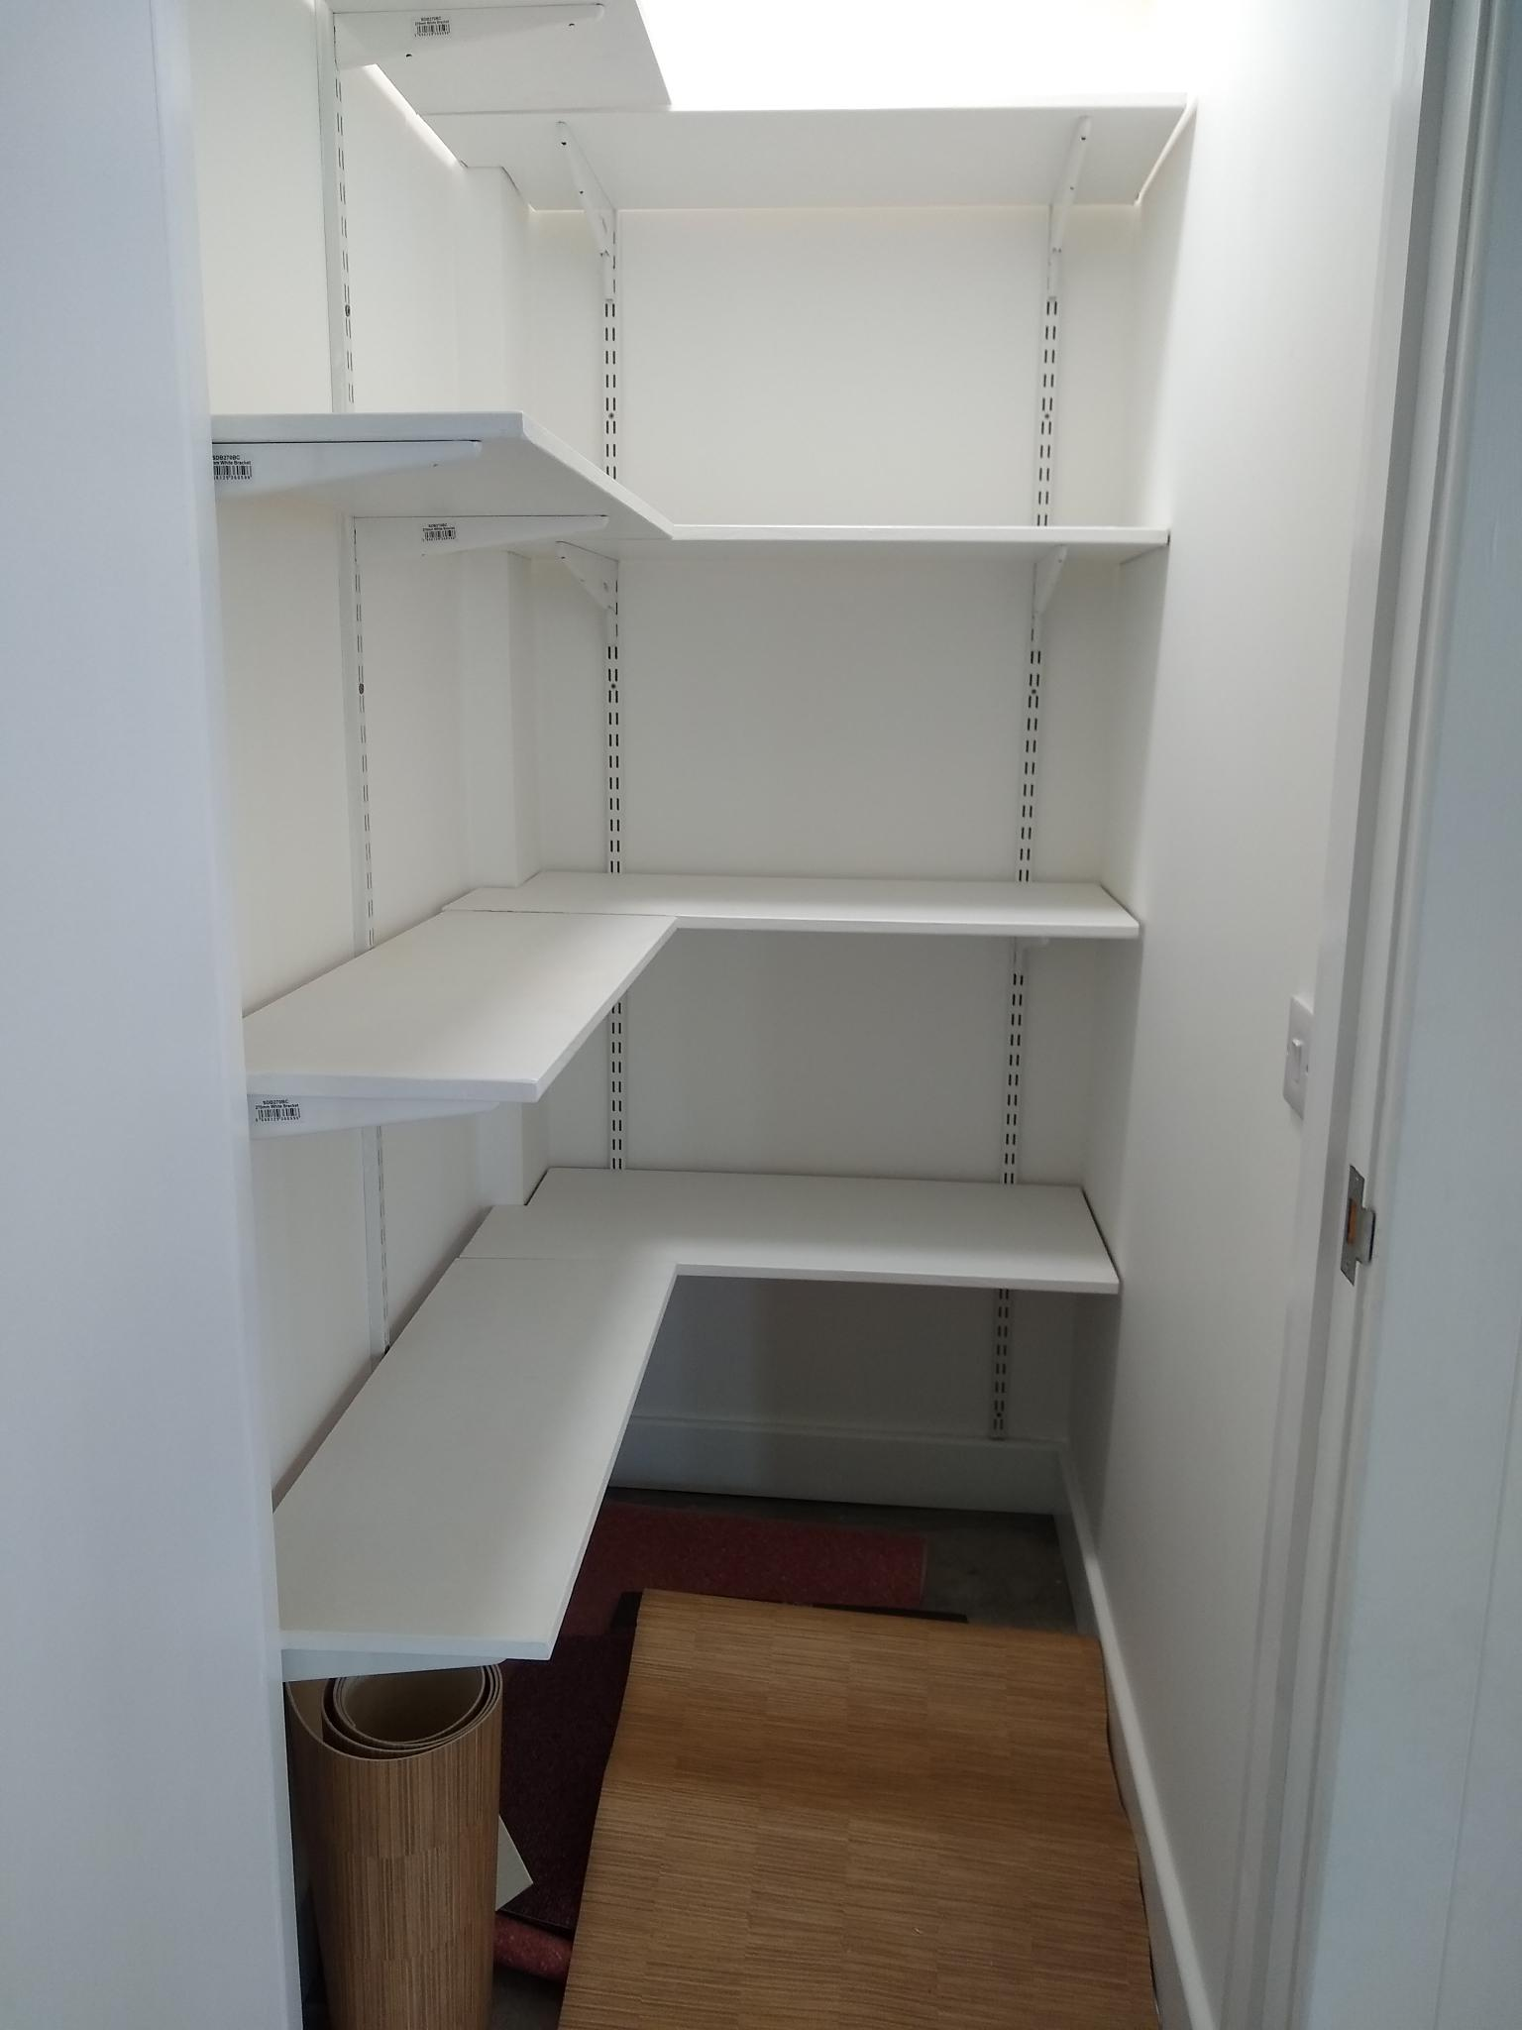

Four shelved cupboards have been created out of the old corridor which linked the kitchen with the main stair.
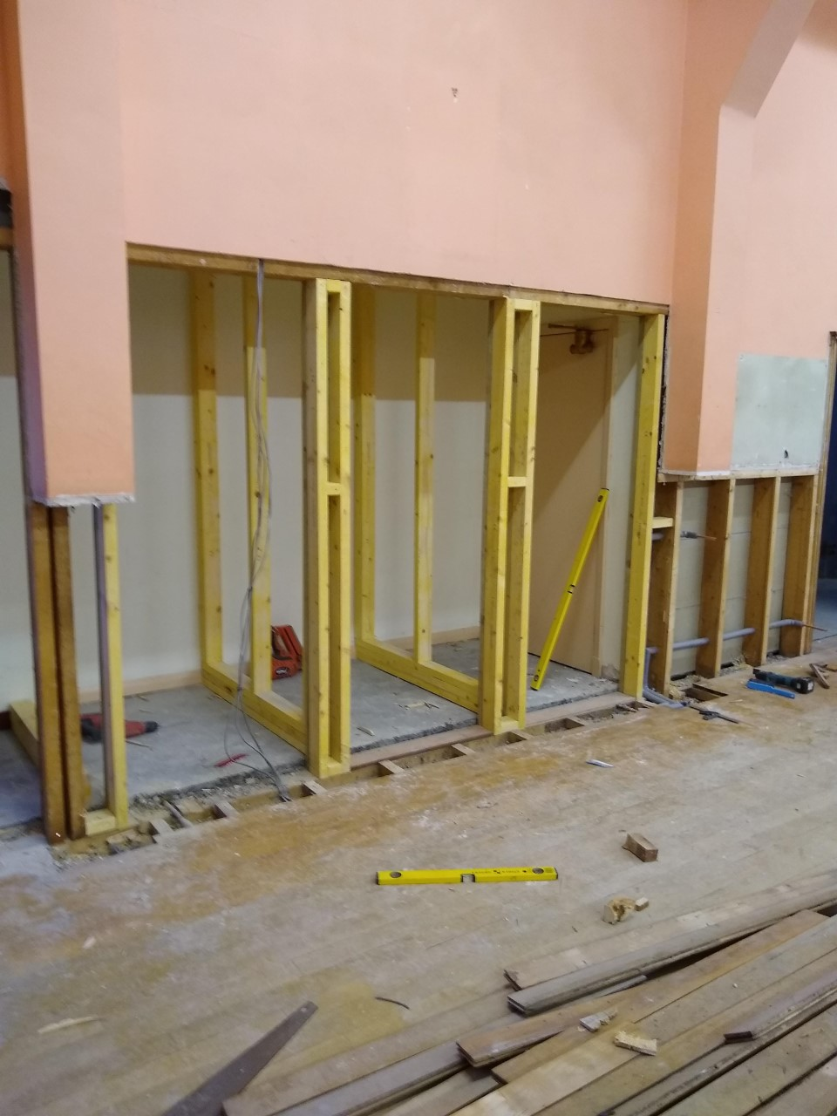
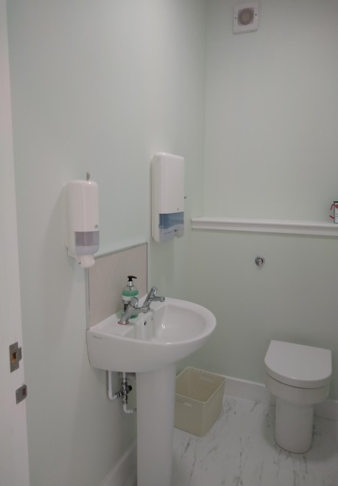
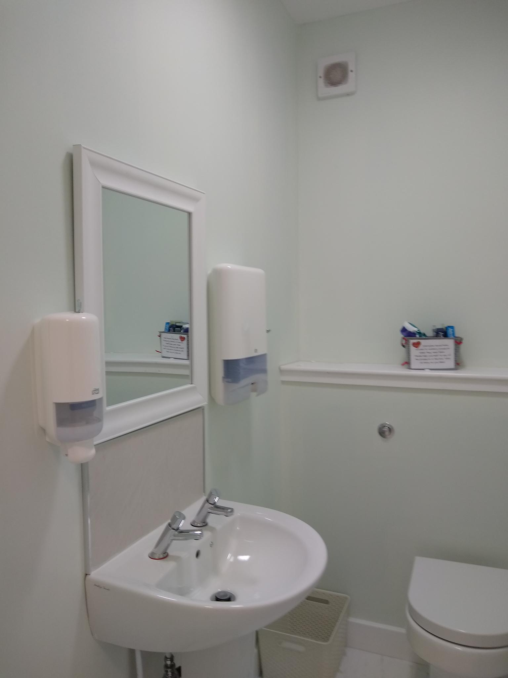

The kitchen which had lain almost empty for years is now fully fitted. There is a dishwasher, large cooker, microwave, a tall fridge and an urn, together with plenty of cupboards.
It is finished in shades of grey.

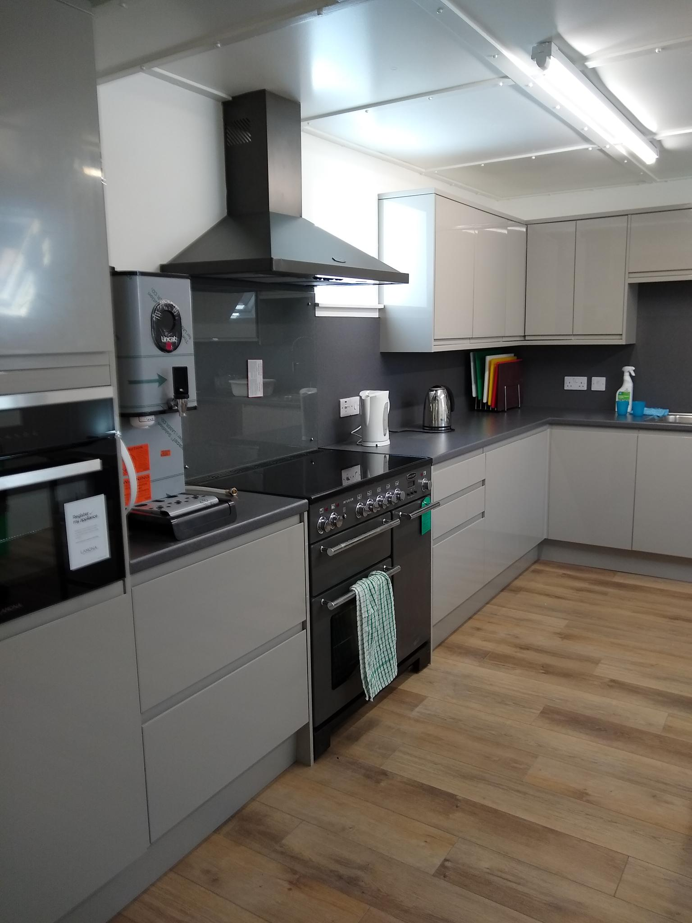
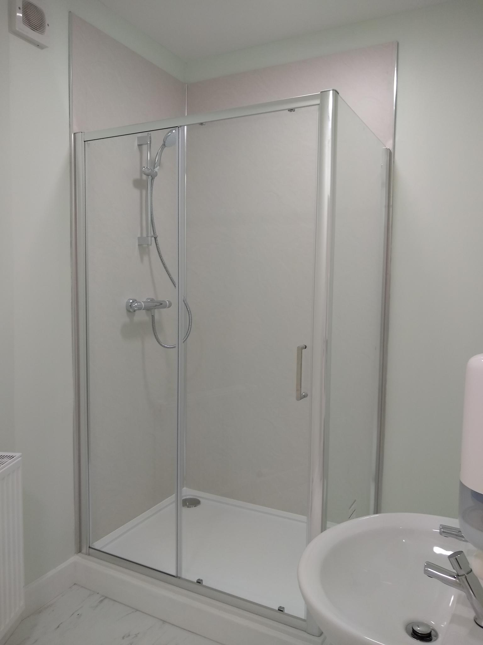

A new toilet suite is in place, with three unisex toilet cubicles and an accessible toilet. A shower is also provided.

A utility room opens off the hall and messy art and craft and paint can be cleared up in the sink here.
It also houses a washer-drier and a small freezer, and provides extra cupboard space.

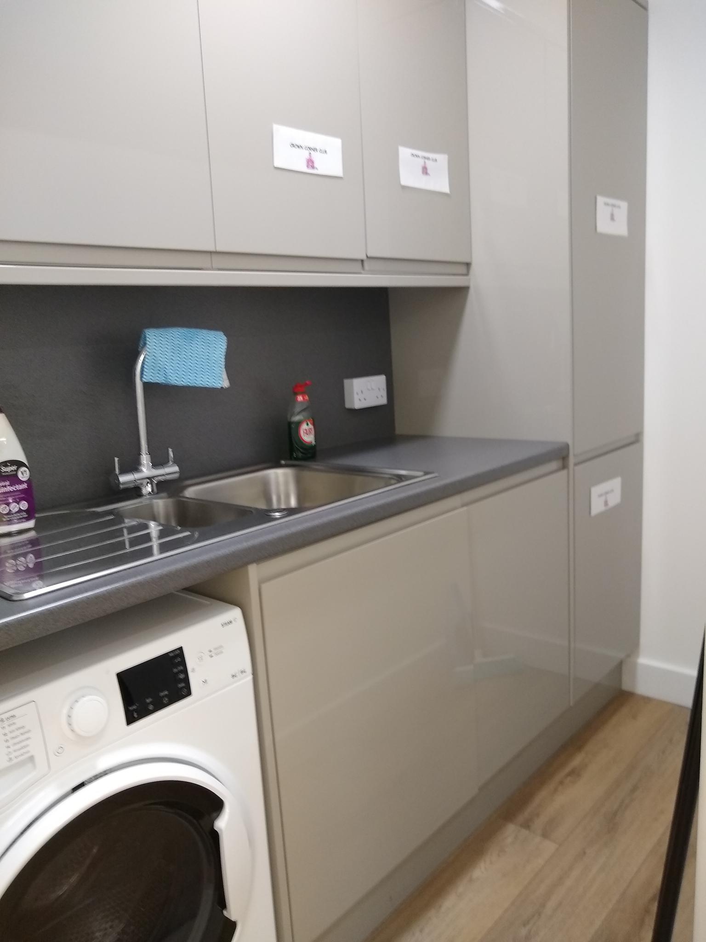

Leaders with the responsibility for children in the upper hall can control access. Parents arriving at the Midmills door to collect their children can be seen on the monitor, and the leader can speak to them on the phone, or open the door remotely.
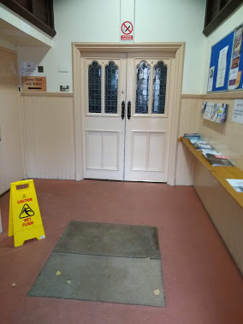
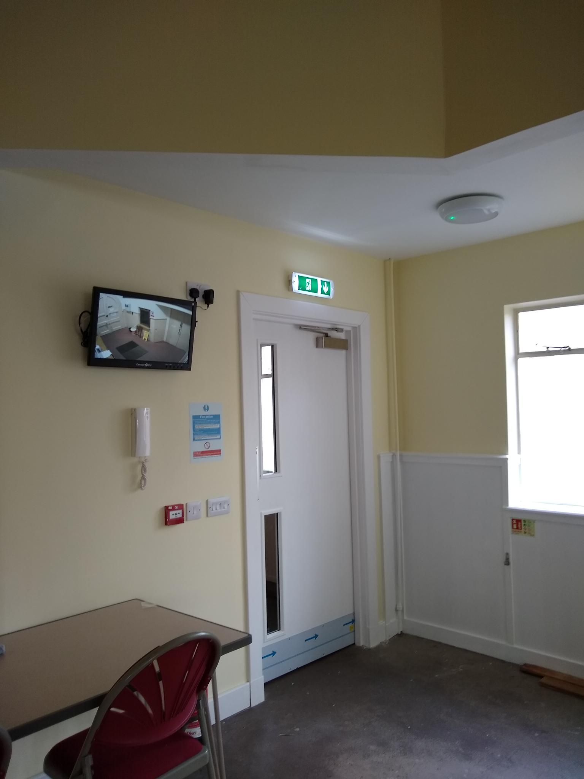

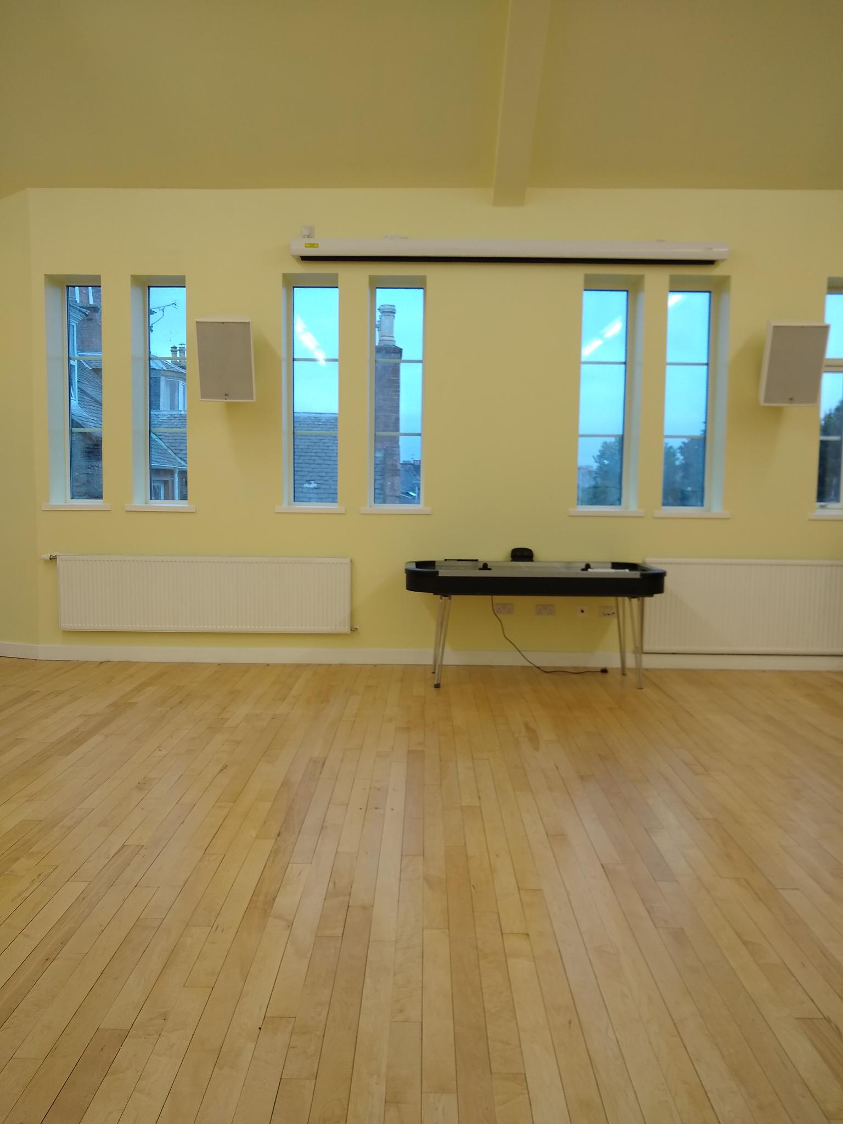

State of the art Audio Visual equipment is installed. The screen will open downwards in front of the back windows when the blackout blinds are drawn.

Note also the floor finish. The upper hall already had a well sprung floor which has been retained but has been sanded and polished.

The final development is that the new lift will come up into the centre of the demolished stage. Large storage cupboards are on either side of it. The completion date for the lift is the end of October as it is being installed as part of the work downstairs.
With the onset of the pandemic, the planned congregational fundraising effort had to be abandoned. The work was mainly paid for out of our congregational reserves, by grants from the Common Good Fund (£30,000), the Highland Council’s Ward Discretionary Fund (£9,500),the Community Climate Asset Fund(£9,956) and by an appeal to the congregation which raised the magnificent total of £34,126 (inclusive of Gift Aid).

And Downstairs
Work downstairs in our halls will be ongoing until the end of 2021. We have agreed a long lease of our lower hall to the Highland Council who have drawn up plans to turn it into Nursery accommodation for Crown Primary School next door to us. They have contracted Morrisons to carry out the work which is programmed to be finished by the end of the year.
Highland Council will be paying an annual rent for this accommodation and the provision of land at the back of the kitchen which will be added to some land from the school grounds to make a garden for the children to play in. Also included in the rent is the use of the kitchen to serve lunches, and the small hall to be the dining area during nursery hours. Crown Church is benefitting by the provision of new toilets, a refurbished kitchen, the installation of a lift to the upper hall, and a newly built enclosed fire escape. As the Crown area does not have a Community Centre, this work will benefit the local community who will have increasing opportunities once all the refurbishments have been completed to book space in our buildings for a variety of activities.

