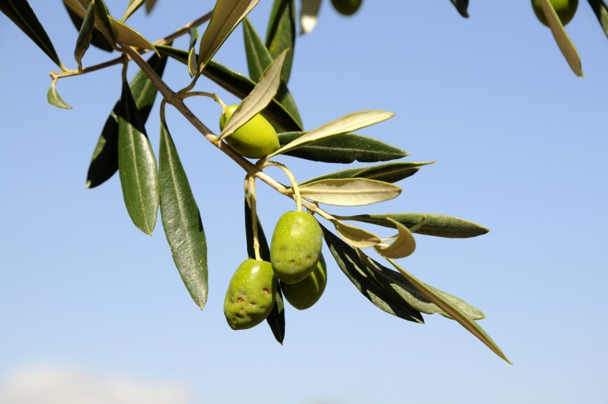
THE
OLIVE
GROVE

After operating for 10 years before lockdown in our Kingsmills tearoom, we have now re-opened in Crown. If you can spare a morning or afternoon a fortnight and would like to join our wonderful volunteers, please contact Marian on 07752 961360.
