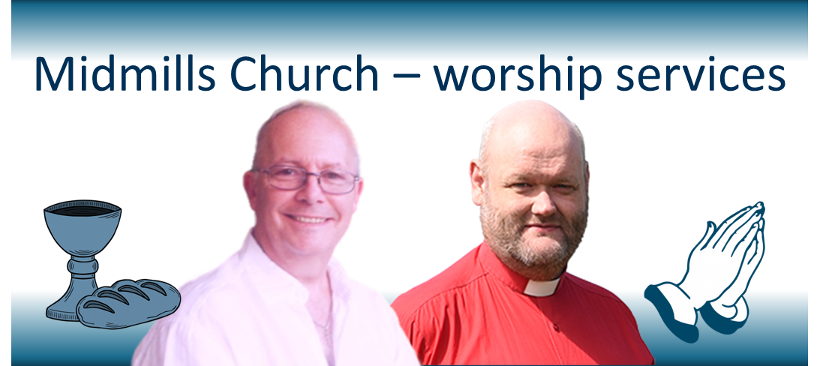

Midmills Parish Church comes into being on New Year’s Day – and the first united services, on Sunday 4th January at 9.30am and 11.00am, will both include Communion as we come together in union. Rev Doug McRoberts and Rev James Bissett will share in leading these services, and through January and February will then share responsibility for leading the more formal of the two weekly services – at 11.00am each week – while the more informal all-age family services at 9.30am will be led by a united worship team.
All Sunday services will be in the former Crown Church building on Midmills Road, with the 9.30 services featuring worship around tables, and children’s activities feeding into the worship, while the 11.00 services will be more formal in nature, featuring a wide variety of traditional and newer hymns, with the service centred on hearing God’s Word through Bible reading and preaching. This service will be enhanced by the singing of the united choir.
Both services will be followed by refreshments – at 10.15, a chance for both gatherings to meet together over a cup and a chat in the sanctuary, and after the later service a “sit down cuppa” in the upper hall.
This will set the pattern for regular Sunday worship in the united congregation. We look forward to welcoming everyone in worship and fellowship.

